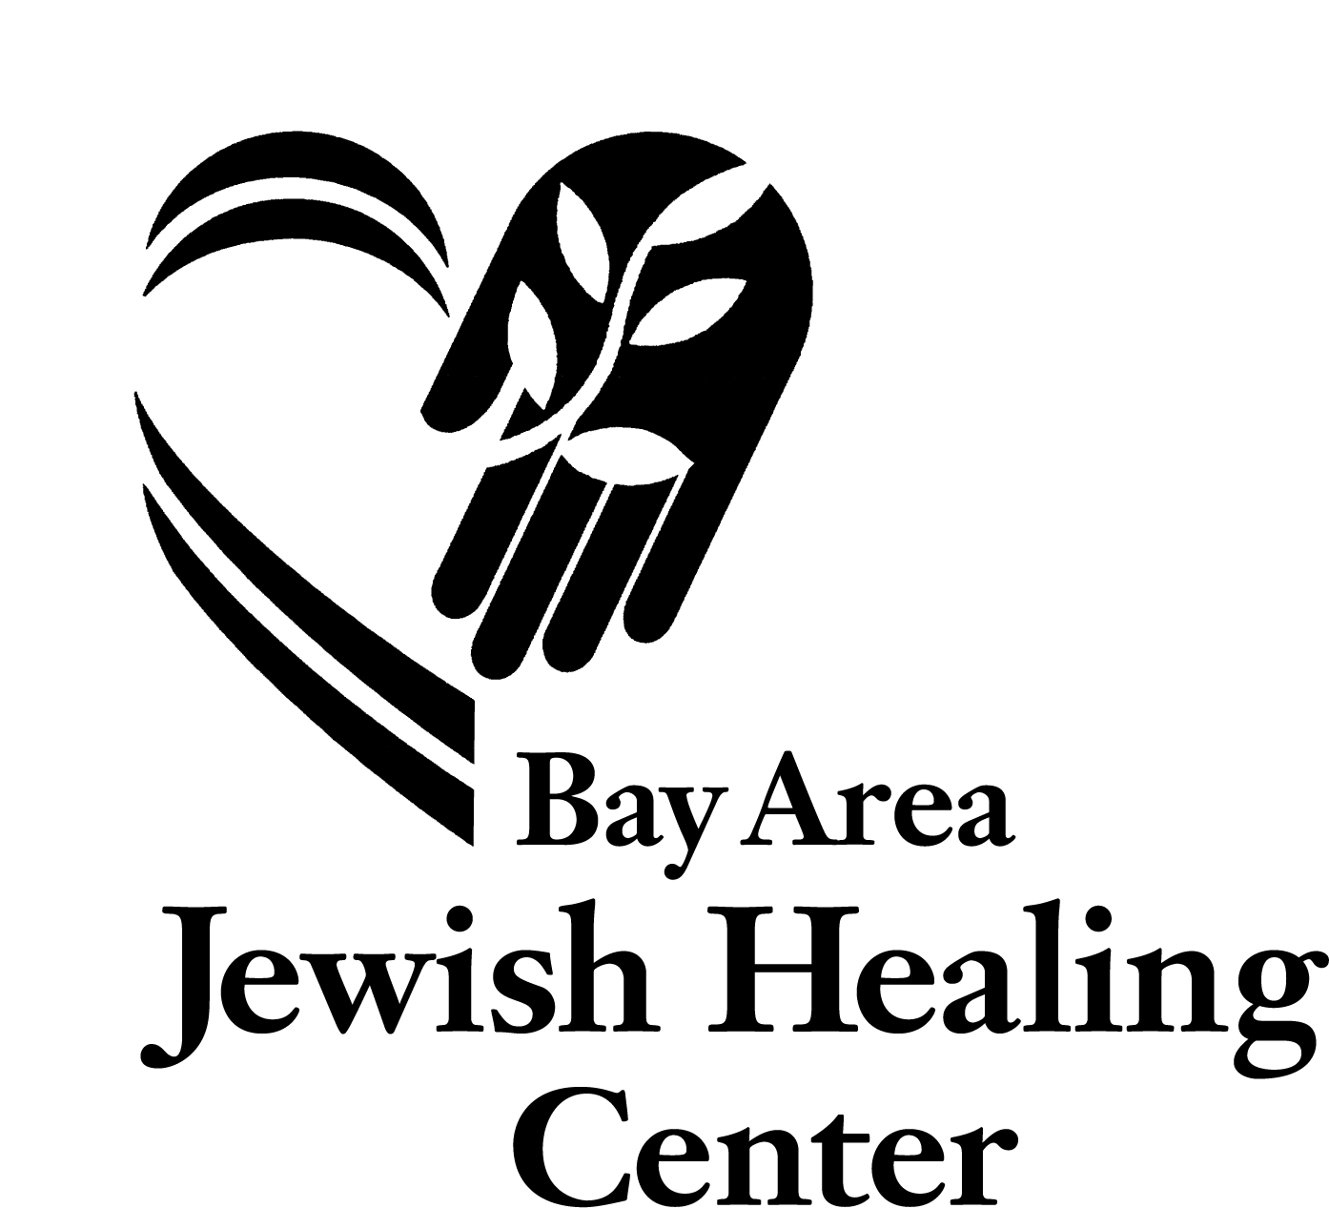

Volunteer Application for Kol Haneshama: Jewish End of Life Care⁺
The Bay Area Jewish Healing Center in collaboration with the San Francisco Campus for Jewish Living is seeking volunteers*

Thank you for your interest in Kol Haneshama: Jewish End of Life Care volunteer program. The Hebrew words “Kol HaNeshama” come from Psalm 150 and refer to the phrase “Let every breath/everything that breathes praise God.” Our primary site is the San Francisco Campus for Jewis Living where volunteers are matched with elderly residents nearing the end of life. Each volunteer receives thorough training, is closely supervised by rabbinic mentors and is supported by a community of peers. No prior experience in health care or Jewish knowledge or belief is necessary.

An application form is attached. After returning a completed application, you will be notified by the Healing Center, and told whether or not you will be scheduled for an interview. Acceptance into the program is based on your application and interview. You may return your completed application anytime. Once we fill a training group, applications will be held over for the following training. The dates for the 2019 training are:
June 18, 20 – 5:30 -9:30pm
June 22-23 – 9am-6pm
June 25, 27 – 5:30-9:30pm

You must be able to attend all training sessions. In addition to the training, new volunteers will be asked to make a one-year commitment to serve one 4-hour shift per week and attend support group meetings and learning sessions every month.

The fee for the program including meals and all materials and training sessions is $350 for those who intend to volunteer with us and $650 for community participants to defray costs. There is financial support available for volunteers and no one who wants to volunteer will be turned away for financial reasons. Community participants are encouraged to seek full or partial financial support from their synagogue or sponsoring organization.

Space is limited and admissions are rolling. Please submit your application as soon as possible. If you have any additional questions about the volunteer program, please contact Rabbi Elliot Kukla at ekukla@bajhc.org

⁺ Bay Area Jewish Healing Center is a beneficiary of the
Jewish Community Federation of San Francisco, the Peninsula, Marin and Sonoma Counties.
Partial funding for Kol Haneshama is provided by the Walter and Elise Haas Fund, the Maimonides Fund of the Jewish Community Federation of San Francisco, the Peninsula, Marin and Sonoma Counties, and Sinai Memorial Chapel.

Kol Haneshama: Jewish End of Life Care
Volunteer Application

Date______________________

Name ________________________________________
Home Phone: __________________

Address________________________________________
Cell Phone: __________________

Email: _________________________________________

Date of Birth____________
What is your cultural identification? _________________________

How did you hear about the program? Flyer 0 Advertisement 0 Internet 0 Friend 0 Other____________

Do you have a car at your disposal?________

Are you presently working/studying? Full 0 or Part-time 0

What is your occupation/course of study?

___________________________________________________

Do you have previous volunteer experience? (Please describe briefly.)

What do you look for in a volunteer experience?

New volunteers will be asked to make a one-year commitment to serve one shift per week and to attend support group meetings and learning sessions.

To have the most enriching volunteer experience it is ideal to be available Tuesdays, 12-1:30pm at The Campus for Jewish Living in San Francisco (302 Silver Ave at Mission St), for peer support and enrichment sessions, however it is not required for participation. If you are not available on Tuesdays, we will make an individualized plan for your support.

Please specify times during the week/weekend that you may be available.

Weekdays: Morning 0 Afternoon 0 Evening 0
Weekends: Morning 0 Afternoon 0 Evening 0

Please describe the nature of your Jewish connection.

Have you recently experienced a loss through death? _____ If so, please describe briefly and include the date of the loss.

Have you spent time with someone very sick and/or dying? _______ If so, please describe briefly:

Tell us why you want to be an End of Life volunteer. Please respond to the following questions as thoughtfully, but succinctly as you can, exploring your feelings and intentions.

- How do you see your role as an end-of-life volunteer?

- Please describe any personal experience with serious illness (your own or that of someone close to you), and its effect on you.

- Please describe your feelings about and experience with nursing homes or other institutionalized elder care setting.

- Many of the people we serve have varying amounts of dementia or cognitive decline. Please describe your experiences working with dementia and any fears you have or challenges you imagine in this work?

- We frequently visit patients who are no longer verbal or who are unresponsive and cannot communicate either physically or verbally and it is not clear if they are able to understand. How have you in the past, or how do you imagine, connecting with someone non-verbally? What emotions does this bring up for you?

- What kinds of patients or situations would you anticipate having the most difficulty working with and why?

- Describe your personal experience with grief and your feelings about the grieving process.

- Please describe what tools you use to get through hard times (such as friends, family, therapy, nature, synagogue, art, or humor)?

- Describe at least one situation in which you provided care to someone in need.

10.Name at least one thing you are hoping to learn more about through this volunteer experience.

- Why have you chosen Kol Haneshama: Jewish End of Life Care over other volunteer opportunities?

- How do you feel about the time and energy required to volunteer with Kol Haneshama?

- Do you anticipate anything which may interfere with fulfilling the one-year commitment, e.g. family obligations, possible plans for relocation, future study?

- Any additional thoughts that come up for you in completing this application or anything else you would like us to know?

Thank you for considering the Kol Haneshama: Jewish End of Life Care as an opportunity for volunteering and service. We appreciate the time and thought involved in completing this application. If you have any questions as you move through the application, please don’t hesitate to email Rabbi Elliot Kukla at ekukla@bajhc.org. Please send or email your completed application to:
Bay Area Jewish Healing Center
ATTN: Rabbi Elliot Kukla
2530 Taraval St, suite 202
San Francisco CA 94118

