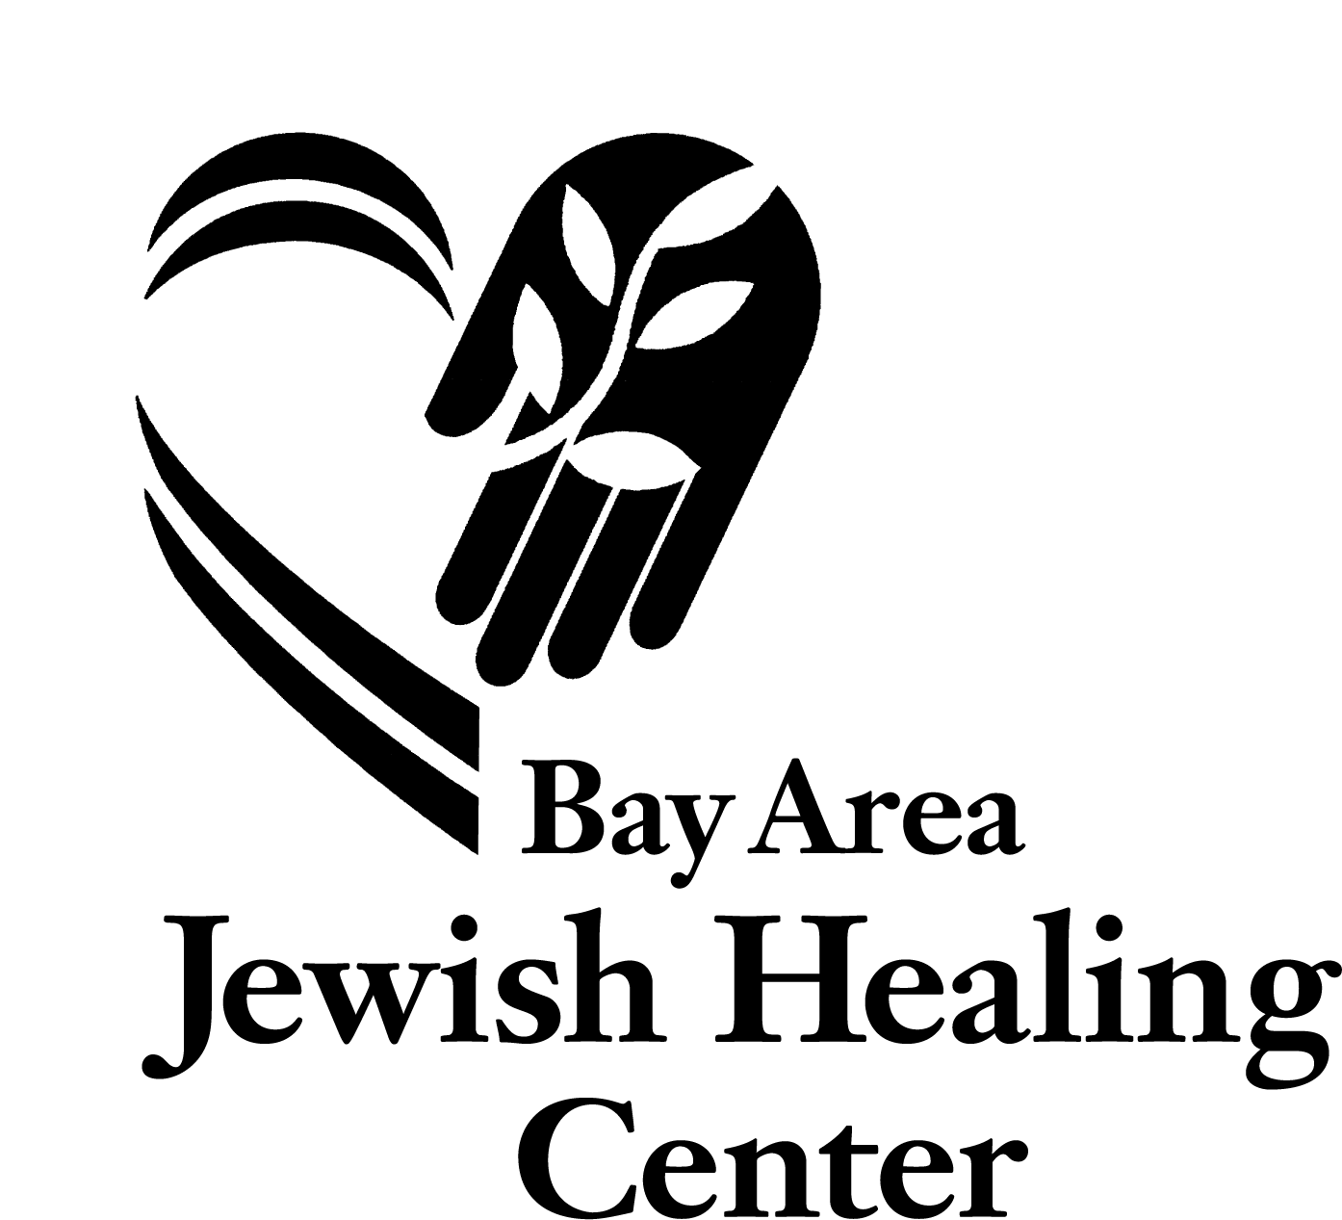

Bereavement Spiritual
Support Group

For those living with the loss of a loved one

Where: Bay Area Jewish Healing Center
2530 Taraval Street, Suite 202
San Francisco, CA 94116

When: Group meets on Thursdays

March 22 – May 17, 2018

Time: 5:30pm. – 7:30pm.

Fee: $100 (financial options available)

Facilitated by Rabbi Elliot Kukla

For more information please call (415) 750-3440

or email Ekukla@bajhc.org

This spiritual support group is made possible, in part, by the generous tzedaka of the Bernard Osher Jewish Philanthropies Foundation of the
Jewish Community Endowment Fund of the Jewish Community Federation of San Francisco, the Peninsula, Marin and Sonoma Counties.
We thank them for their gracious understanding of spiritual support in the face of grief.

2530 Taraval Street, Suite 202 • San Francisco, CA 94116 • Tel: (415) 750-4197 • Fax: (415) 750-4115 • www.Jewishhealingcenter.org

Group meets Thursdays
March 22 – May 17, 2018

Bay Area Jewish Healing Center
2530 Taraval Street, Suite 202, San Francisco

Facilitator is Rabbi Elliot Kukla, Bay Area Jewish Healing Center

For more information, call Rabbi Kukla at Bay Area Jewish Healing Center at (415) 750-3440

Registration for: Spiritual Support Group for Those Living with the Loss of a Loved One

Name: _________________________________________________________

Street Address: ___________________________________________________________________

City: ________________________________________ State: _____________Zip:_____________

Cell Phone: _______________________ Evening Phone:_________________________________

E-mail:____________________________

Name of the person(s) you are grieving: ____________________ ____________
Your relationship to the person(s) you are grieving: ____________

Date(s) of Losses: ________________________________________________________________

I am returning my registration form for the Spiritual Support Group with a check for:

 $100 (payment in full), OR
 $25 deposit (to hold my place; the deposit will apply toward the full fee), OR
 $25 deposit and I will contact you this week to discuss a possible fee adjustment

Space is limited; please return this form to:
Bay Area Jewish Healing Center
2530 Taraval Street, Suite 202, San Francisco, CA 94116

