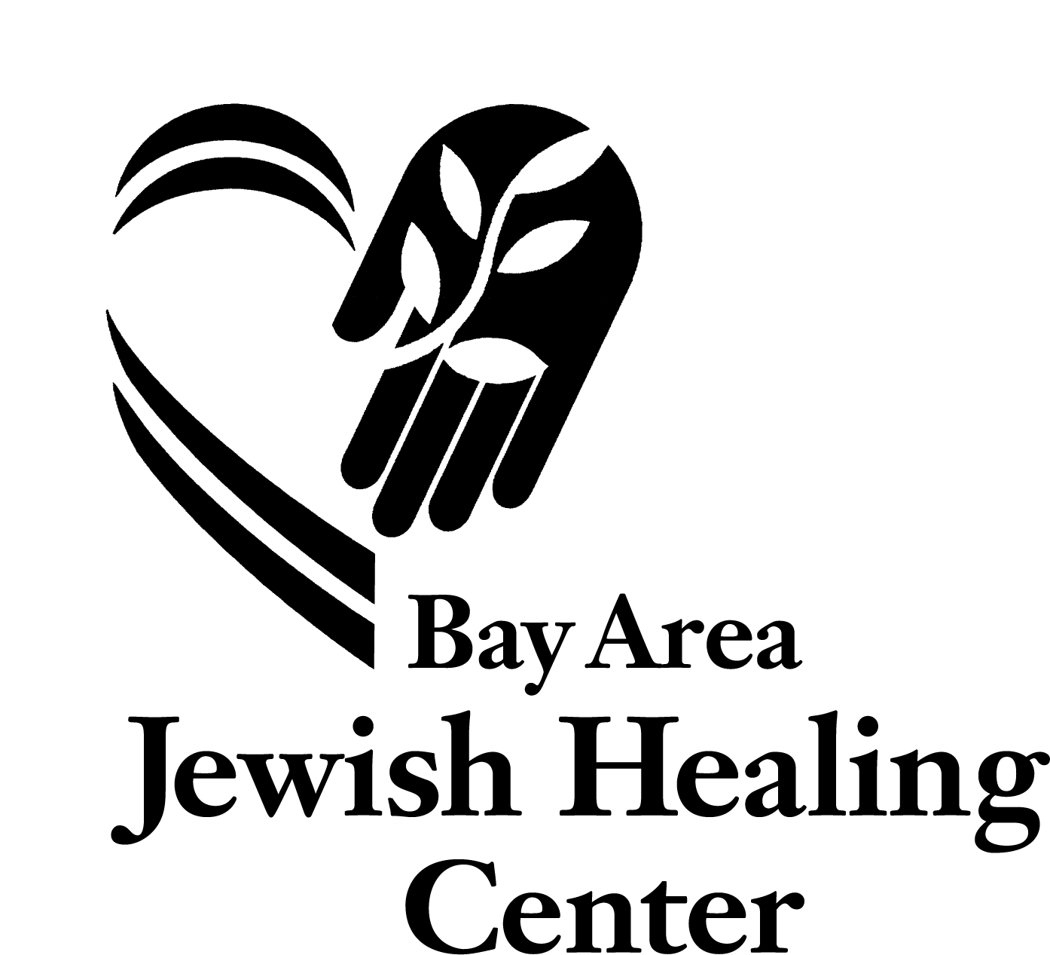
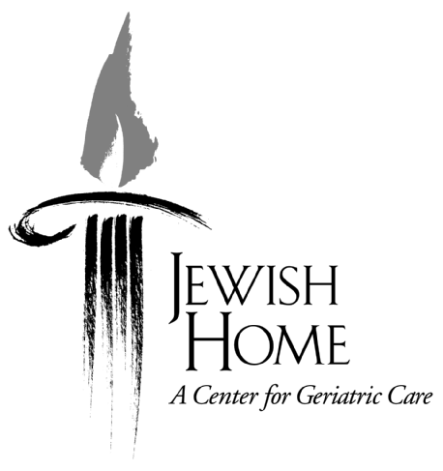
Zen Hospice Project

Volunteer Training Application for Kol Haneshama: Jewish End of Life Care⁺
The Bay Area Jewish Healing Center in collaboration with Jewish Home of San Francisco is seeking volunteers*

Thank you for your interest in Kol Haneshama: Jewish End of Life Care volunteer program. The Hebrew words Kol HaNeshama come from Psalm 150 and refer to the phrase “Let every breath/everything that breathes praise God.” Our primary site is the Jewish Home in San Francisco where volunteers are matched with elderly residents nearing the end of life and/or beginning to explore end of life issues. Each volunteer receives thorough training, is closely supervised by rabbinic mentors and is supported by a community of peers. No prior experience in health care or Jewish knowledge is necessary; we each have the capacity to empathetically care for another.
An application form is attached. The Bay Area Jewish Healing Center screens all applicants. After returning a completed application, you will be notified by the Healing Center, and told whether or not you will be scheduled for an interview. Acceptance into the program is based on your application and interview. You may return your completed application anytime. Once we fill a training group, applications will be held over for the following training.
The dates for the 2017 training are:

June 20, 22 – 6 -9:30pm, Mercy Center in Burlingame
June 24-25 – 9am-6pm, Mercy Center in Burlingame
June 27, 29 – 6-9:30pm, Jewish Home of San Francisco

You must be able to attend all training sessions. If you are able to participate in the next training, we encourage your thoughtful and reflective completion of this application. Full participation in each of the seven days of training is required. In addition to the training, new volunteers will be asked to make a one year commitment to serve one 4-hour shift per week and attend support group meetings and learning sessions every month.
The fee for the program including most meals and all materials and training sessions is $350 for those who intend to volunteer with us and $650 for community participants to defray costs. There is financial support available for volunteers and no one who wants to volunteer will be turned away for financial reasons. Community participants are encouraged to seek full or partial financial support from their synagogue or sponsoring organization.

Space is very limited and admissions are rolling. Please submit your application as soon as possible. If you have any additional questions about the volunteer program, please contact Rabbi Elliot Kukla at ekukla@bajhc.org

⁺ Bay Area Jewish Healing Center is a beneficiary of the
Jewish Community Federation of San Francisco, the Peninsula, Marin and Sonoma Counties.
Partial funding for Kol Haneshama is provided by the Walter and Elise Haas Fund, the Maimonides Fund of the Jewish Community Federation of San Francisco, the Peninsula, Marin and Sonoma Counties, and Sinai Memorial Chapel.
* Zen Hospice Project’s collaboration is funded in part by grants from the PacifiCare Foundation and the E. Rhodes and Leona B. Carpenter Foundation.

Zen Hospice Project

Kol Haneshama: Jewish End of Life Care
Caregiver Volunteer Application

Date______________________

Name ________________________________________ Home Phone: __________________

Address________________________________________ Cell Phone: __________________

Email: _________________________________________

Date of Birth ____________What is your cultural identification? _________________________

How did you hear about the program? Flyer 0 Advertisement 0 Internet 0 Friend 0 Other____________

Do you have a car at your disposal? ___

Are you presently working/studying?____ Full 0 or Part-time 0

What is your occupation/course of study _____________________________________________

Do you have previous volunteer experience? (Please describe briefly.)

What do you look for in a volunteer experience?

Do you have special skills (i.e. health care, counseling, massage, foreign languages, cooking, art, music, or other) you think might be helpful)? Please describe briefly:

New volunteers will be asked to make a one-year commitment to serve one shift per week and to attend support group meetings and learning sessions – our primary support meeting time is Tuesday from 12-1:30pm

To have the most enriching volunteer experience it is ideal to be available Tuesdays, 12-1:30pm, for peer support and enrichment sessions, however it is not required.

Please specify times during the week/weekend that you may be available.

Weekdays: Morning 0 Afternoon 0 Evening 0
Weekends: Morning 0 Afternoon 0 Evening 0

Please describe the nature of your Jewish connection.

Have you recently experienced a loss through death? _____ If so, please describe briefly and include the date of the loss. Please include any spiritual practice that you engaged in as a part of the dying or grieving process.

Have you spent time with someone very sick and/or dying? _______ If so, please describe briefly:

Tell us why you want to be an End of Life volunteer. Please respond to the following questions as thoughtfully, but succinctly as you can, exploring your feelings and intentions.

1. What is your understanding of end-of-life care?

2. How do you see your role as an end-of-life volunteer?

3. Please describe any personal experience with serious illness (your own or that of someone close to you), and its effect on you.

4. Please describe your feelings about and experience with nursing homes or other institutionalized elder care settings.

5.Many of the people we serve have varying amounts of dementia or cognitive decline.Please describe your experiences working with dementia and any fears you have or challenges you imagine in this work?

6. We frequently visit patients who are no longer verbal or who are unresponsive and cannot communicate either physically or verbally and it is not clear if they are able to understand. How have you in the past, or how do you imagine, connecting with someone non-verbally? What emotions does this bring up for you?

7. What kinds of patients or situations would you anticipate having the most difficulty working with and why?

8. Describe your personal experience with grief and your feelings about the grieving process.

9. What are the sources of emotional and spiritual support you have in your life right now (such as friends/family/therapy/nature/synagogue/art/humor…)?

10. Briefly describe something that helps you get through hard times.

11. Describe at least one situation in which you provided comfort to someone in need.

12. Name at least one thing you are hoping to learn more about through this volunteer experience.

13.Why have you chosen Kol Haneshama: Jewish End of Life Care over other volunteer opportunities?

14. How do you feel about the time and energy required to volunteer with Kol Haneshama?

15. Do you anticipate anything which may interfere with fulfilling the one-year commitment, e.g. family obligations, possible plans for relocation, future study?

16.Any additional thoughts that come up for you in completing this application or anything else you would like us to know?

Thank you for considering the Kol Haneshama: Jewish End of Life Care as an opportunity for volunteering and service. We appreciate the time and thought involved in completing this application. If you have any questions as you move through the application, please don’t hesitate to email Rabbi Elliot Kukla at ekukla@bajhc.org. Please send or email your completed application to:
Bay Area Jewish Healing Center
ATTN: Rabbi Elliot Kukla
2530 Taraval St, suite 202
San Francisco CA 94118

